### Stevens Institute of Technology



TrainX Architects

IoT Hug the Rail

v.1.0

Bonnie Nguyen, Roma Razdan, Matthew Viafora, and Michael Zylka

Software Development Process

Professor Peyrovian

### **Section 1:**

#### **Introduction:**

Using the internet of things, our group will devise a method to allow decisions to be made locally in absence or failure of cellular and wifi. This will be implemented into the Train System (Hug the Rail) as a means of making it safer, less costly, and more efficient.

Our team consists of several smart, problem-solving, communicative individuals who strive to create an innovative design. Mike is a creative individual who will take the proper initiative to learn about the best possible solution for our project. Matt is a member who is very detail oriented and will ensure that the work we produce is truly working to create a safer, less costly, and more efficient solution. Bonnie is someone who is very task oriented and will help the overall flow of the project move smoothly, and Roma is someone who is people-oriented and will ensure that this model will be user-friendly and meet all the stakeholders’ criteria.

Together this team, otherwise known as TrainX Architects, will work together to revolutionize the future of railroads as we know it today. We are looking to innovate the current solution, as well as looking for new ways to expedite the user’s experience while maintaining a connection to our design.

Our personal perspective on this project is to produce a system (engine) that informs the user of the train about current conditions, then to have an interface that allows the conductor to manipulate the train speeds according to that information. While this is rather general, we will work to pose a more detailed solution to our problem as we move through the planning process that this project will entail.

We see ourselves working to continue planning, then soon to begin modeling, construction, and deployment. After that we will reevaluate and communicate with our stakeholders and our group to ensure we are meeting their expectations. We have yet to create deliverables where we set due dates for each aspect of our project but we look forward to making more progress in reaching our goals.

**Timeline:** 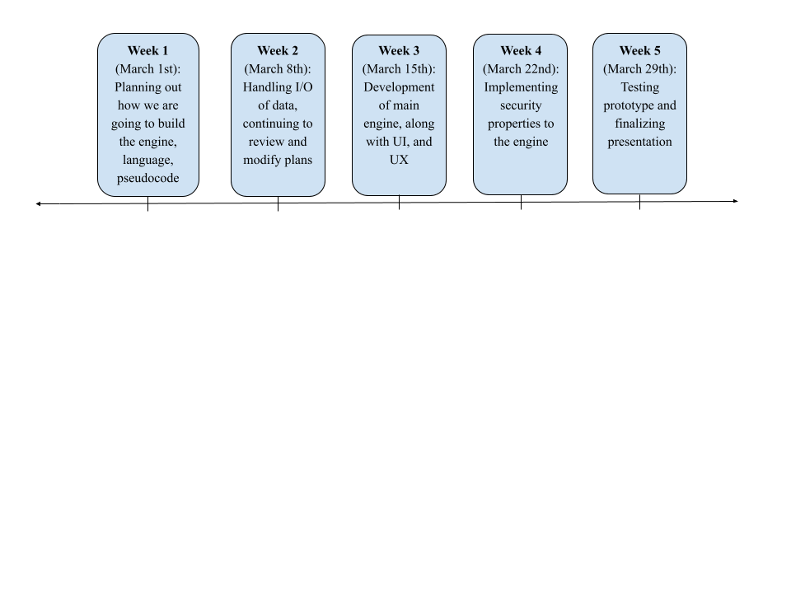

**Model:**

(Spiral Process Model)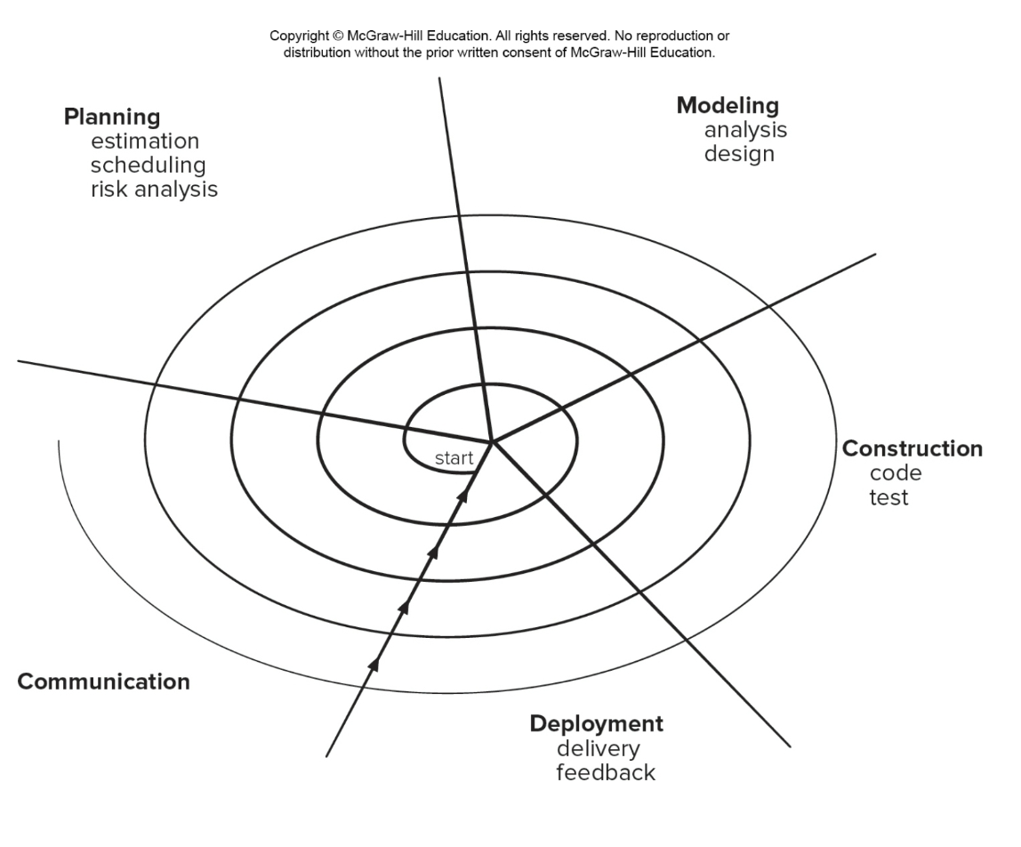

|  |  |
| --- | --- |
| Pros | Cons |
| * Continuous customer involvement * Development risks are managed * Suitable for large, complex projects * Allows to change * Works well for extensible products | * Risk analysis failures can doom the project * Project may be hard to manage * Requires an expect development team |

### **Section 2:**

**Problem Statement:** The train operation depends on live data received from the Central Operation Center Servers via WiFi/Cellular network. We need to be able to operate the train when we lose WiFi/Celluar network. We need to develop a system to allow us to continue the trip safely based on local data that we can collect. We assume GPS data is available.

**System Overview**

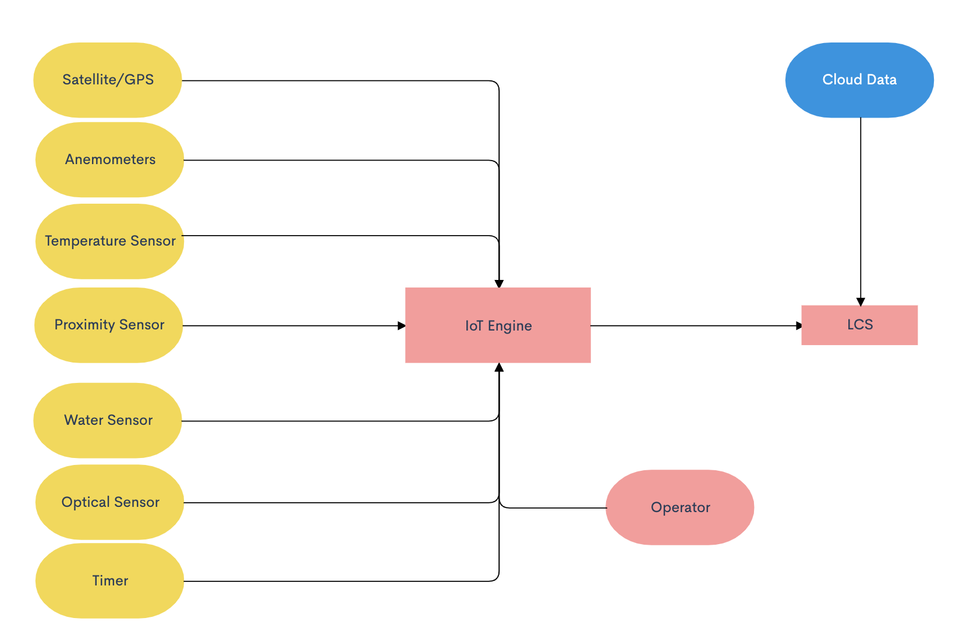

* Using installed sensors and computers outlined in the flowchart above, the IoT engine will take in different inputs from the data collected by the external sensors.
* The operator also has input into the IoT engine as they have power to adjust any part of the IoT engine including the speed of the train. The operator may have access to information that is not collected by the external sensors via radio, visual, etc.
* The IoT engine utilizes the data collected from these different sensors and/or if the operator influences anything and dynamically adjusts the throttle to brake or speed up appropriately.
* The LCS also has access to cloud data previously collected before the train lost connection, any previous data of value including arrival and departure times can be used until connection is regained.

**Data Required**

* Weather condition (such as snow, ice, rain, and wind)
* Hazards on the track both front and back
* Gate opening and closing times
* Arrival and departure times

**Technology Required**

* Temperature
  + Temperature sensor will measure the temperature outside and work with the optical sensor to determine an ideal speed for the train while not connected.
* Optical sensor
  + Ensure that the train does not start “slipping” on tracks and the locomotive is kept in control the entire time.
* Proximity sensor
  + In order to detect hazards on the railway both in front and in back of the train, there will be proximity sensors placed on the train that will work with IoT in order to determine if a change in the locomotive speed should occur.
* Water Sensor
  + Water sensors should be placed in strategic locations on the train in order to properly monitor weather conditions outside. Depending on the severity of the weather conditions, the water sensor should interface with the IoT to properly determine the ideal travel speed for the train.
* Timer
  + In order to properly arrive at gates on time and be prepared to stop in case of a scheduled downed gate or terminal, all arrival and departure times should be downloaded before losing connection. The IoT will work with this pre-downloaded data in order to determine the proper speed to arrive on time and not too early or too late.
* Anemometers
  + In case of harsh weather conditions, the locomotive should be prepared to travel with caution. An anemometer to measure wind speeds should be programmed to collaborate with the IoT architecture to determine if the train should travel at a cautious speed.
* Satellite Technology/GPS
  + Rely on GPS technology to determine the current position and direction of the train. Data can be drawn from the GPS to ensure the train stays on its intended route and not conflict with other trains in the area.
  + GPS also provides data on the speed of the train to interface with the other sensors and IoT in order to accommodate for outside conditions.